Project Design Phase
Solution Architecture

Date | 3 July 2026
Team ID
Project Name | RK-HEALTH
Maximum Marks | 4 Marks

Solution Architecture:
Solution architecture is a complex process – with many sub-processes – that bridges the gap between business problems and technology solutions. Its goals are to:
- Find the best tech solution to solve existing business problems.
- Describe the structure, characteristics, behavior, and other aspects of the software to project stakeholders.
- Define features, development phases, and solution requirements.
- Provide specifications according to which the solution is defined, managed, and delivered.

Example - Solution Architecture Diagram:

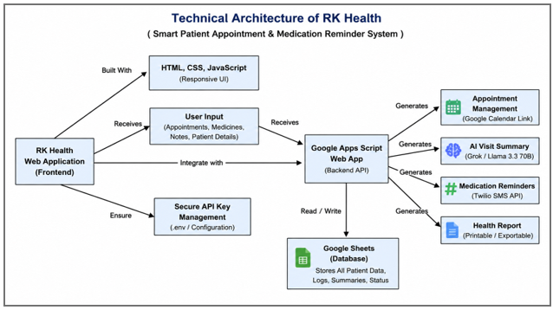
Figure 1: Technical Architecture of RK-HEALTH (Smart Patient Appointment & Medication Reminder System)

RK-HEALTH Solution Architecture Layers
Layer | Components | Tech Stack | Role & Interaction
Presentation Layer (Frontend) | Single Page Application (SPA), Glassmorphism UI, 3D Login background, Dark Mode | HTML5, CSS3, ES6+ JS, Three.js, Font Awesome 6 | Handles direct user interactions, local rendering, theme switching, and client-side notifications.
Application Logic Layer | Local DB Wrapper, State Manager, AI Symptom Triage, Calendar Link Generator | Vanilla JS, Web localStorage API | Manages client-side CRUD logs, local user authentication, and formats request payloads.
Backend API Gateway | Flask REST Server, Twilio Wrapper, GAS Sheets Proxy | Python 3.13, Flask, Gunicorn | Handles routing for SMS reminders, enables CORS, and acts as secure proxy for Google Sheets sync.
Data & Integration Layer | Browser storage, cloud sync database, serverless AI API | localStorage API, Google Sheets (via Apps Script), Groq API (LLaMA 3.3-70B) | Persists user data offline-first, syncs logs to Sheets for cloud backup, and processes chat queries.

